Tode-RC
Users Guide

Setup and Operation


http://www.TGit-Tech.com
Firmware Version: 232H
Last Updated: 2023-02-22

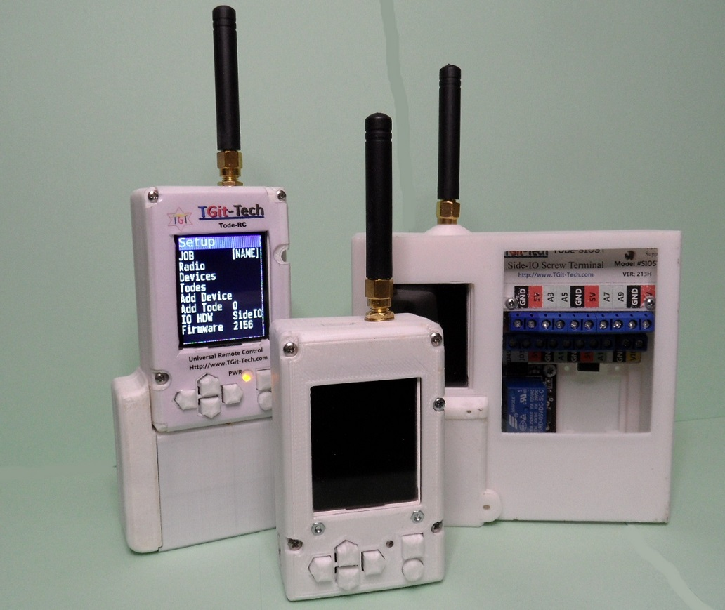

Contents

Table of Contents
1. Contents 2
2. Introduction 3
2.1 Specifications 4
2.2 Menu Structure 5
3. Configure 6
3.1 Set Name 6
3.2 Radio Settings 7
3.2.1 Requirements 7
3.2.2 Per-Digit Setting 7
3.2.3 Value Setting 8
3.3 IO HDW Setting 9
3.4 Adding Devices 10
3.5 Device Control 11
3.6 Add Tode (Remote) 12
3.7 Deleting 13
3.7.1 Deleting Devices 13
3.7.2 Deleting Remote Todes 13
3.7.3 Factory Reset 13
4. IO Devices 14
4.1 Common Settings 14
4.2 OnOff 14
4.3 AnaInput 14
4.4 AnaOutput 15
4.5 Distance 15
4.6 STSTP3W 16
5. Automation (Logic) 16
5.1 SetPoint 16
5.2 Math 17
6. System 18
7. MQTT Control 19
7.1 Tode Setup 19
7.2 OpenHab Server Setup 19
7.2.1 Openhabian 19
7.2.2 Putty 20
7.2.3 MQTT Broker & Client 20
7.2.4 Serial2MQTT 21
7.2.5 OpenHab 22
A. MQTT /get Value Update 22

Introduction

- The Tode Project is a Universal Platform of...

  - User Inter-Face Options
  - Back-plane Models optional Radio & Arduino Micro-Controller
  - Extensions - IO Interfaces, Battery Trays

The Tode System is licensed under the MIT License.
It's hosted on Github.com at: https://github.com/TGit-Tech/Tode-RC

Specifications

- Remote-Control Tested Distance
  - Test Setup
    - (2) Todes set at Tx Power 30dbm
    - (2) Todes having a 5dbi 20cm Omni antenna
    - Stationary Tode antenna mounted 12ft above ground level
    - Rural Area.
  - Signal can reasonably be used at 2-miles away
  - Signal can be spot gotten (hard to get) at 3-miles away
  - There is no signal past 3-miles

Menu Structure

- Multiple Todes make-up a remote-control network-of Individual Todes.

  - The particular Tode in subject is self-described as This-Tode.
  - Each Tode that is accessible on This-Tode has its own Tode-Screen.
    - Tode-Screen are ordered Horizontally
      - Left-most = This-Tode ( use button to switch left )
      - Right-most = Last Remote-Tode accessible (use button)

Power-On 1st Screen  This-Todes  Tode-Screen | Press Right on  This-Todes  Tode-Screen  Goes to 2nd,3rd, etc.... Remote  Tode-Screens  On Initial Power-ON nothing changes because there are NO other Remote Todes added at this Time. | Press on  This-Todes  Tode-Screen  Goes to This-Todes  Setup-Screen

- Sub-Level Menu Screens ( From This-Todes SETUP Screen )
  - Selecting Radio and will produce Sub-Level Radio Settings.
GET
  - Selecting Add Device and will produce Add a Device Screen.
GET
  - Selecting Del Tode and will produce List of Todes.
GET
  - To Exit a Sub-Level Screen press the button.

Configure

Set Name
- Enter a Name for This-Tode
On SETUP Screen | SETUP, 'Set Name' | SETUP,'Set Name'
Press to the blank [NAME] field.  Press | On 'Set Name' Screen  Press | Text Entry Field highlights (Blue)
Text Entry Field is Red when not selected else Blue when Selected by .
Once Selected (BLUE) Character Position (WHITE) can be Selected by
SETUP  'Set Name'  Entering a Name | SETUP  'Set Name'  Saving & Exiting | SETUP
To Edit or Clear a Character Position; Highlight the Text Field (BLUE) and select the character to replace (WHITE) then choose the replacement character press SET. The BLANK character is directly under the “EXIT”.

Radio Settings

Requirements
- Radio Settings that must be identical for Tode Communication.
SecNet  (Range 01-7F) | Security Code selected by you that prevents unauthorized access to your Tode network.
Frequency  (410 to 441)MHz | The radio frequency (channel) for Tode Communication.

- Radio Setting that must be Unique
Address  (Range 0000-FFFE) | A radio address to identify each Tode uniquely decided upon by you.

- Other Radio Settings
Tx Power  (21,24,27,30)dBm | Sets the (Tx) Transmitting Power of the Radio.  Lower saves power, Higher transmits farther.
PC Connex  (On -or- Off) | When set to On it ties the radio terminal to the USB Port.  This a special function generally ignored by users.

Per-Digit Setting
- Choose any SecNet Value between 01 to 7F and Set that Value.
SETUP | SETUP  RADIO | SETUP  RADIO (Per-Digit Set)
to select Radio.  Press | to select SecNet  to select Value | Press to change.  Press again to set.
SecNet and Address use Per-Digit Set where each digit is changed at a time.
The WHITE background indicates the selected digit. Use to change the selected digit and to change the digits value. Going beyond the number of select-able digits will exit setting without saving changes.

- Choose any *Unique* Address Value for this Tode between 0001 and FFFE and set that Value the same way Per-Digit Set as done to set SecNet.
        - In this example Address is set to 1112.

Value Setting
- Choose any Frequency between 410MHz and 441MHz (default is 433MHz).
  - The chosen frequency must be identical on all Todes expected to communicate with each other.

SETUP  RADIO | SETUP  RADIO | SETUP  RADIO (Value Set)
to Frequency | to select Value | Press to change.
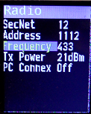
to Increment Value  to Decrement Value | Press to save Value.  to Frequency | again to SETUP

- Choose the lowest Tx Power level that will sustain communications.

IO HDW Setting

- A Tode that has connected devices must know what IO HDW is used to connect the devices. If the Tode will be used only as a hand-held control device, then setting the IO HDW is not needed.

  - At the time of this writing the only option for connecting devices is a SideIO Plug (SIOST stands for SideIO with Screw Terminals).

SETUP | SETUP | SETUP
to IO HDW | to select Value  (I.e. 'NotSet' in picture) | then or  select SideIO  to set the value
 | 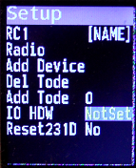

- NOTICE: If the IO HDW has not been set before trying to set a device PIN the Tode will notify you with SetHDW as shown below.

Adding Devices

See 5.1 Section for more information on Device Support and Setup.

SETUP | SETUP  Add Device | This-Tode
or  select Add Device  Press | or  Select Device to Add.  Press | The added device appears as ?NAME?  0 is the Device Index #
 |  | 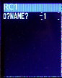
This-Tode  Select Device | Selected Device  =Device Set Name | Selected Device  =Device Setup
select 0?NAME? | Press enter Set Name  for the Device.  Same routine as setting a Tode name. | Re-Select Device.  Press enter Setup  Enter Device specific Setup Settings (Ex. Only)
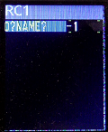 |  | 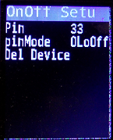  Note: OLoOff  Output Low, when Off

Device Control

Below shows an example of how to change an Output Device’s State.

This can be done on LOCAL (This-Tode) devices or devices on Remote Todes.
To add a Remote Tode see 3.6.Add Tode (Remote)

NOTE: Remote Tode Devices will show a value of ‘?’ until the readings are requesting by pressing .

This-Tode | This-Tode | This-Tode
select RELAY1  to select Value Value 'Off'  Press | to set a new value.  change Value  to set the value | Once set to 'On'  Relay1 on pin 33 should activate.

Add Tode (Remote)
- To Remotely Control another Todes Devices.
  - The “Remote” Tode (RC1 with RELAY1:IO-Device used this far)
  - is added to a new Tode (RC2)

- Obtain a 2nd Tode
  - Repeat Steps 3.1.Set Name and Name the 2nd Tode RC2
  - Assign a *Unique* Radio Address to RC2
RC2 Radio Settings | Required | RC1 Radio Settings
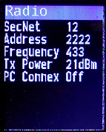 | SecNet has to Match.  Address must be different / unique.  Frequency has to Match.
On Tode RC2
 | add RC1 by Address | Check for an RC1 “remote” Tode Screen.
select Add Tode | to select Value  to set RC1-Address | Again to load RC1  RC1 remote Screen
 | 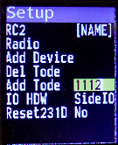
Now the Devices on RC1 can be controlled by RC2.
If the “remote” Tode RC1 failed to show up; try again closer to the unit.

Deleting

Deleting Devices
To Delete a Device enter the Device Setup Screen as shown in 3.4.Adding Devices and select Del Device and press .

Deleting Remote Todes
To Delete a Remote Tode control screen. Select Del Tode on the SETUP menu and then select the Remote Tode by Name on the list and press .

Factory Reset
Preforming a factory reset deletes the Tode Name and all Devices and Remote Todes. Radio Setting are preserved. To preform this operation…

select Reset????  Note: The 4-Digit after Reset is the Firmware Version Loaded.  Firmware 231D | to select Value  to set  to set Yes  again to apply. | The Tode will automatically Reboot and the blank Tode screen will show.

IO Devices

Common Settings
- Every Device Setup has a Del Device option.

- Every Pin has a corresponding pinMode option.
  - OLoOff = Output Low, when Off – Active High
  - OHiOff = Output High, when Off – Active Low
  - InHigh = Input Pull-Up(High) – Active Low
  - InLow = Input Low – Active High (Default Setting)

OnOff

 | On Off Device Setup Screen
 | Pin | Can be any Pin Selectable
 | pinMode | See pinMode options in #4.1.Common Settings
 | Del Device | Select and to delete this device.

AnaInput

The equation for Value = (Pin-Reading + PreAdd) * (MultNum/MultDen) + Add.
MultDen cannot be 0 so 0 equivocates to 10K (10,000)
 | On Off Device Setup Screen
 | Pin | The Pin to read from (must be an ‘A’ pin)
 | pinMode
 | PreAdd | 1st Add this amount to the Pin reading.
 | MultNum | 2nd Multiply by fraction (Fraction Numerator)
 | MultDen | (Fraction Denominator)
 | Add | 3rd Add after fraction multiply (i.e. offset value)
 | Samples | Number of reading to gather and average for value.

AnaOutput

 | AnaOutput is the PWM output operation
 | Pin | Analog Output is Always on PIN #45

Distance

This is used for Sonic Distance Sensors with a Trigger & Echo Pins.

 | Distance Device Setup Screen
 | Trig | The Trigger Pin
 |  | The Trigger Pins pinMode
 | Echo | The Echo Pin
 | EchoPMode | Echo Pins pinMode
 | Samples | Number of Samples to Average for Value

STSTP3W

This is used for panels with a START and STOP momentary push buttons.

 | 3-Wire On/Off Momentary (3-second) Switch
 | StartPin | OUTPUT hat triggers to initiate a START button.
 | StartPMode | StartPin pinMode Setting
 | StopPin | The Pin that triggers to initiate a STOP button.
 | StopPMode | StopPin pinMode Setting
 | Status | INPUT; Pin that determines current state.
 | StatPMode | Status Pins pinMode
 | Del Device | Select and to delete this device.

Automation (Logic)

SetPoint

Compares an Input Device reading to a User SetPoint and if the Input reading is outside the boundaries (+/- Tolerance) then it sets an Output Device respectively.

For example; A tank of water with a level sensor can maintain it’s water level by switching ON or OFF a pump that feeds the tank.

 | On Off Device Setup Screen
 | InputDev | The Device Index to read a value from
 | InTolernc | The (+/-) tolerance allowed from setpoint
 | OutTode | The Tode Index of Out Device (optional) or 0-local
 | OutDev | The Device Index to SET the value on (optional)
 | LOutSet | SET value on OutDev when Input is < setpoint
 | HOutSet | SET value on OutDev when Input is > setpoint
 |  | SET value can be ON or OFF
 |  | Or INCR/DECR where Difference between setpoint

Math

Implements Mathematical Operation on TWO input readings and (Optionally) sends the computed value to an output device if the value breaks tolerance (+/-) boundaries (i.e. Value changes significantly).

 | On Off Device Setup Screen
 | In1Dev | The Device Index to read a value from
 | Operator | (+)(-)(x)(/) plus, minus, times, divide or AVE-average
 | In2Dev | The Device Index to read a value from
 | Tolerenc | +/- Change Tolerance before setting Output
 | OutTode | The Tode Index of Out Device (optional) or 0-local
 | OutDev | The Device Index to SET the value on (optional)

Note: When OutTode is a Remote Tode; values are only sent every 14s when the In-Value passes +/- Tolerance of the last sent value.

System

The System menu allows one to do factory resets, enable MQTT, Soft Reset the unit and lookup the firmware version loaded. Pressing the Okay button on the FWver-???? entry causes the Soft Reset.

 | System Sub-menu
 | USBSerial | What the Top USB plug is used for (auto-reboots)
 | Factry RST | Factory Reset
 | Pub ADiscv | Publish homie MQTT data for Auto-Discovery
 | SRFWv-???? | Soft Reset. Displays current Firmware verson.

- USBSerial allows (3)options
  - NOTICE: Changing the USB-Serial use causes an auto-reboot to occur.
    - None = There is no USB Serial Usage (option for debugging)
    - MQTT = Tode uses USB Serial to communicate with MQTT Server.
    - KBC = Keyboard Control by Serial Input. (For Automated Testing)
        - 8=up 9=Set
      - 4=left, 6=right
        - 2=down 3=Get

- Factry RST erases all Todes and Devices and User-Settings.

- Pub ADiscv publishes ‘homie’ auto-discovery MQTT on-demand.
  - only works when USBSerial=MQTT.

- SRFWv preforms a soft (no-erase) reset on-demand and also displays the loaded firmware version. It can be used to reset without power-cycling after making a new setting for USBSerial or any reason to do just a soft-reset.

MQTT Control

Tode-RC firmware ver.232D+ has support for ‘homieMQTT’ Internet of Things(IoT) control using the Serial plug to connect a Tode to a Raspberry Pi IoT server.

Tode Setup

In SETUP→System→USBSerial set to ‘MQTT’.
See 6.System for details.

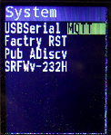

OpenHab Server Setup

Openhabian

Download Raspberry-Pi Imager at https://www.raspberrypi.com/software/

When you run it; It'll ask for…
- Operating System: scroll down and click "Other specific-purpose OS"
  - Pick & Click "Home assistants and home automation"
  - Pick & Click "openHAB"
    - Pick 32-bit as OpenHAB states use 32-bit; works best.
    - Storage: Choose the Flash-Card Target.

- Insert Card into Raspberry-Pi and attach an Ethernet Cable
  - Power the Raspberry Pi and wait a while for boot up process.
  - Connect to the openHAB UI at http://openhabian:8080
  - This may take up to 45-Minutes to become available
  - May have to use MS-DOS">arp -a" command to find it's IP-Address
  - Enter an administrator Username and Password on Startup.
  - Connect to the openHAB Log Viewer (frontail): http://openhabian:9001

Putty

- Install PuttySSH Terminal on a Home PC.
  - See: https://putty.org/

  - Run the Putty terminal
    - Click on Connection Type: SSH
    - Enter Host Name: openhabian
    - click open.

  - Login
    - Username: openhabian
    - Password: openhabian

MQTT Broker & Client

- Login to the Server computer (Raspberry Pi) using ‘Putty’ terminal.

  - Install the MQTT Broker (Mosquitto) on the Raspberry Pi.
    - See: https://community.openhab.org/t/oh3-mqtt-setup-and-configuration/111494
openhabian:~$ sudo apt install mosquitto
openhabian:~$ sudo systemctl start mosquitto
openhabian:~$ sudo systemctl daemon-reload
openhabian:~$ sudo systemctl enable mosquitto

  - Also install MQTT Client (mosquitto-clients) on the Raspberry Pi.
Openhabian:~$ sudo apt-get install mosquitto-clients

  - Visit the above link for enabling outside IP connections if desired.

- Test the MQTT broker setup with mosquitto-clients.

  - Login with a 2nd putty terminal and enter
openhabian:~$ mosquitto_sub -v -t 'test/topic'
  - On the 1st putty terminal send an MQTT publish
openhabian:~$ mosquitto_pub -t 'test/topic' -m 'helloWorld'

verify that the (-m)message ‘helloWorld’ appears on the 2nd terminal.

- Online Instructions for installing an MQTT broker on Raspberry Pi.
  - https://www.openhab.org/addons/bindings/mqtt/

Serial2MQTT

- Install serial2mqtt
  - See: https://github.com/TGit-Tech/Tode-RC-Firmware/tree/main/serial2mqtt_build
openhabian:~$ wget https://raw.githubusercontent.com/TGit-Tech/Tode-RC-Firmware/main/serial2mqtt_build/serial2mqtt.`arch`.zip

openhabian:~$ wget https://raw.githubusercontent.com/TGit-Tech/Tode-RC-Firmware/main/serial2mqtt_build/serial2mqtt.json

openhabian:~$ unzip serial2mqtt.`arch`.zip
openhabian:~$ mv Debug/serial2mqtt.`arch` serial2mqtt

- Setup crontab to auto-run serial2mqtt at start-up
  - Start the crontab editor
openhabian:~$ crontab -e
  - Edit the file adding the following line at the bottom of the file.
@reboot /home/openhabian/serial2mqtt

be sure to save / write changes to file.

- Check operation
  - Reboot (Power-Cycle) the Raspberry Pi Server.

  - Make sure ‘serial2mqtt’ starts after Raspberry Pi reboot
openhabian:~$ ps -x
PID TTY STAT TIME COMMAND
347 ? Ss 0:00 /bin/sh -c /home/openhabian/serial2mqtt
348 ? Sl 0:01 /home/openhabian/serial2mqtt

  - View the ‘serial2mqtt’ logfile
openhabian:~$ tail -f log.serial2mqtt.0.log

  - For debugging; you can launch ‘serial2mqtt’ from the command line.
openhabian:~$ ~/serial2mqtt

  - Attach Tode to the Raspberry Pi by USB cable.
    - Watch the ‘serial2mqtt’ log file as it connects and publishes data.

OpenHab

Inside OpenHab you can now add the MQTT binding which also requires an MQTT thing. Once the Tode publishes it’s ‘homie’ MQTT data the first time a ‘tode’ thing will show up in the ‘inbox’ feature.

However; due to OpenHab bugs after a ‘tode’ thing has been added one must instruct the Tode to send the ‘homie’ data a second time. Go to Todes SETUP menu, to ‘System’ menu and select ‘Pub ADiscv’ (stands for Publish Auto-Discovery data) and push the Okay button.

Only after OpenHab has received the ‘homie’ data a second time will the ‘channels’ show up. The rest of OpenHab setup should be instructed in the OpenHab guide.

The Tode publishes MQTT in the form of homie/tode/todename/devicename (gets) + /set for (sets).

It also publishes MQTT in the form of homie/tode/tstodename/tsdevicename where the ‘ts’ prefix stands for timestamped status. ‘ts’ channels are for (gets) only and appends a hexadecimal millisecond timestamp to the gotten value. ( example; ON-2fe3a1). Using OpenHab label card to show this (gotten) value ensures that the sets are preformed correctly. Watch that the timestamp changes after setting a new value.

MQTT /get Value Update

Once Widgets are setup to turn things on and off.
Using a Label Card to display “ts” values.

- Get the UID of the MQTT Broker by clicking the ‘Copy UID’ symbol.
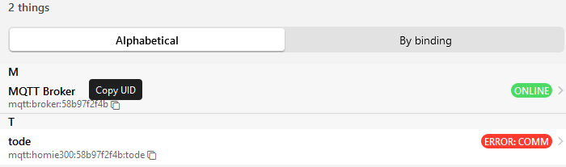
- Create New script named mqttGet
  - Use ‘ECMAScript’
  - actions.get("mqtt","mqtt:broker:58b97f2f4b").publishMQTT("homie/tode/1com6/get","")
  - Paste your MQTT Broker UID in second get() parameter. And adjust the publish MQTT for the ‘TodeName’ for the /get.
- Setup the Label Widget to run the ‘GetScript’ when clicked.
  - Under Action choose ‘Run rule’
  - Click Rule and select ‘mqttGet’ for the ‘script name’.

